**Dispenser Test**

Done by Romain Nith on the 27/03/2017

Problem: Determine the allowed robot-dispenser distance error.

Setup: Robot place next to the dispenser. Let the ball fall into the dispenser and record for each incrementation in one axis the result

The origin is set on the robot arm’s middle for the Y-axis and the edge for the X-axis (+)

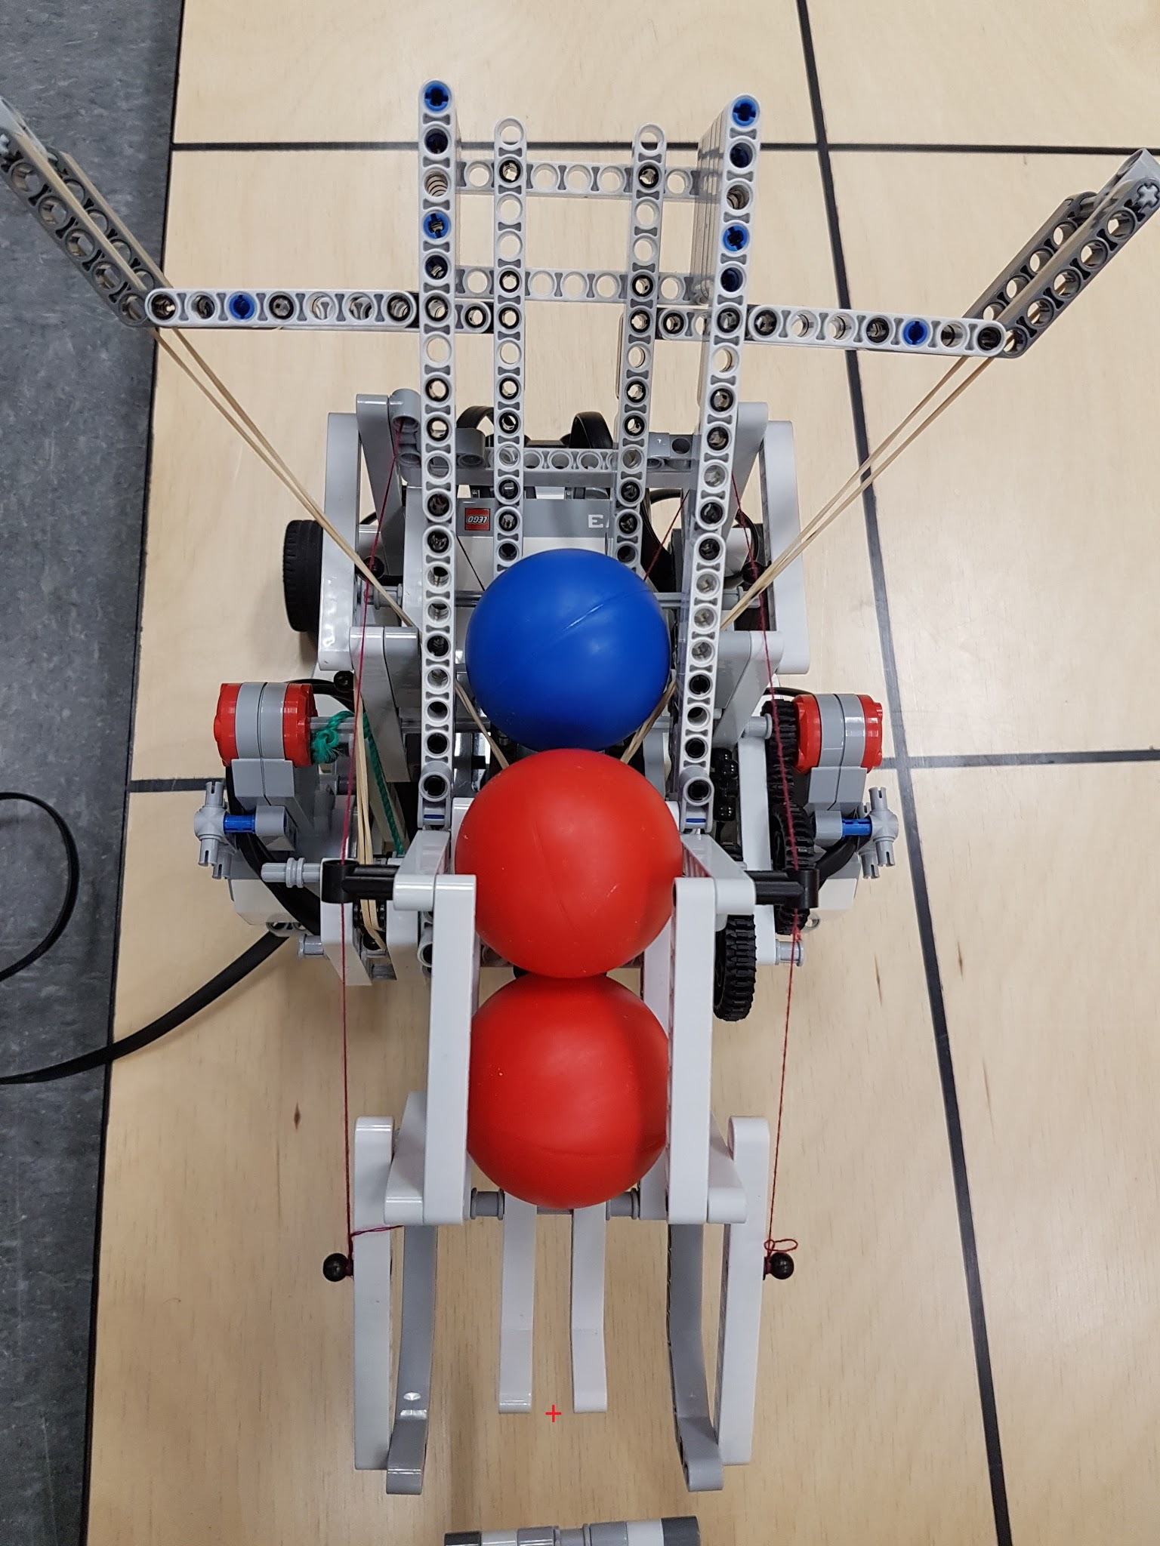

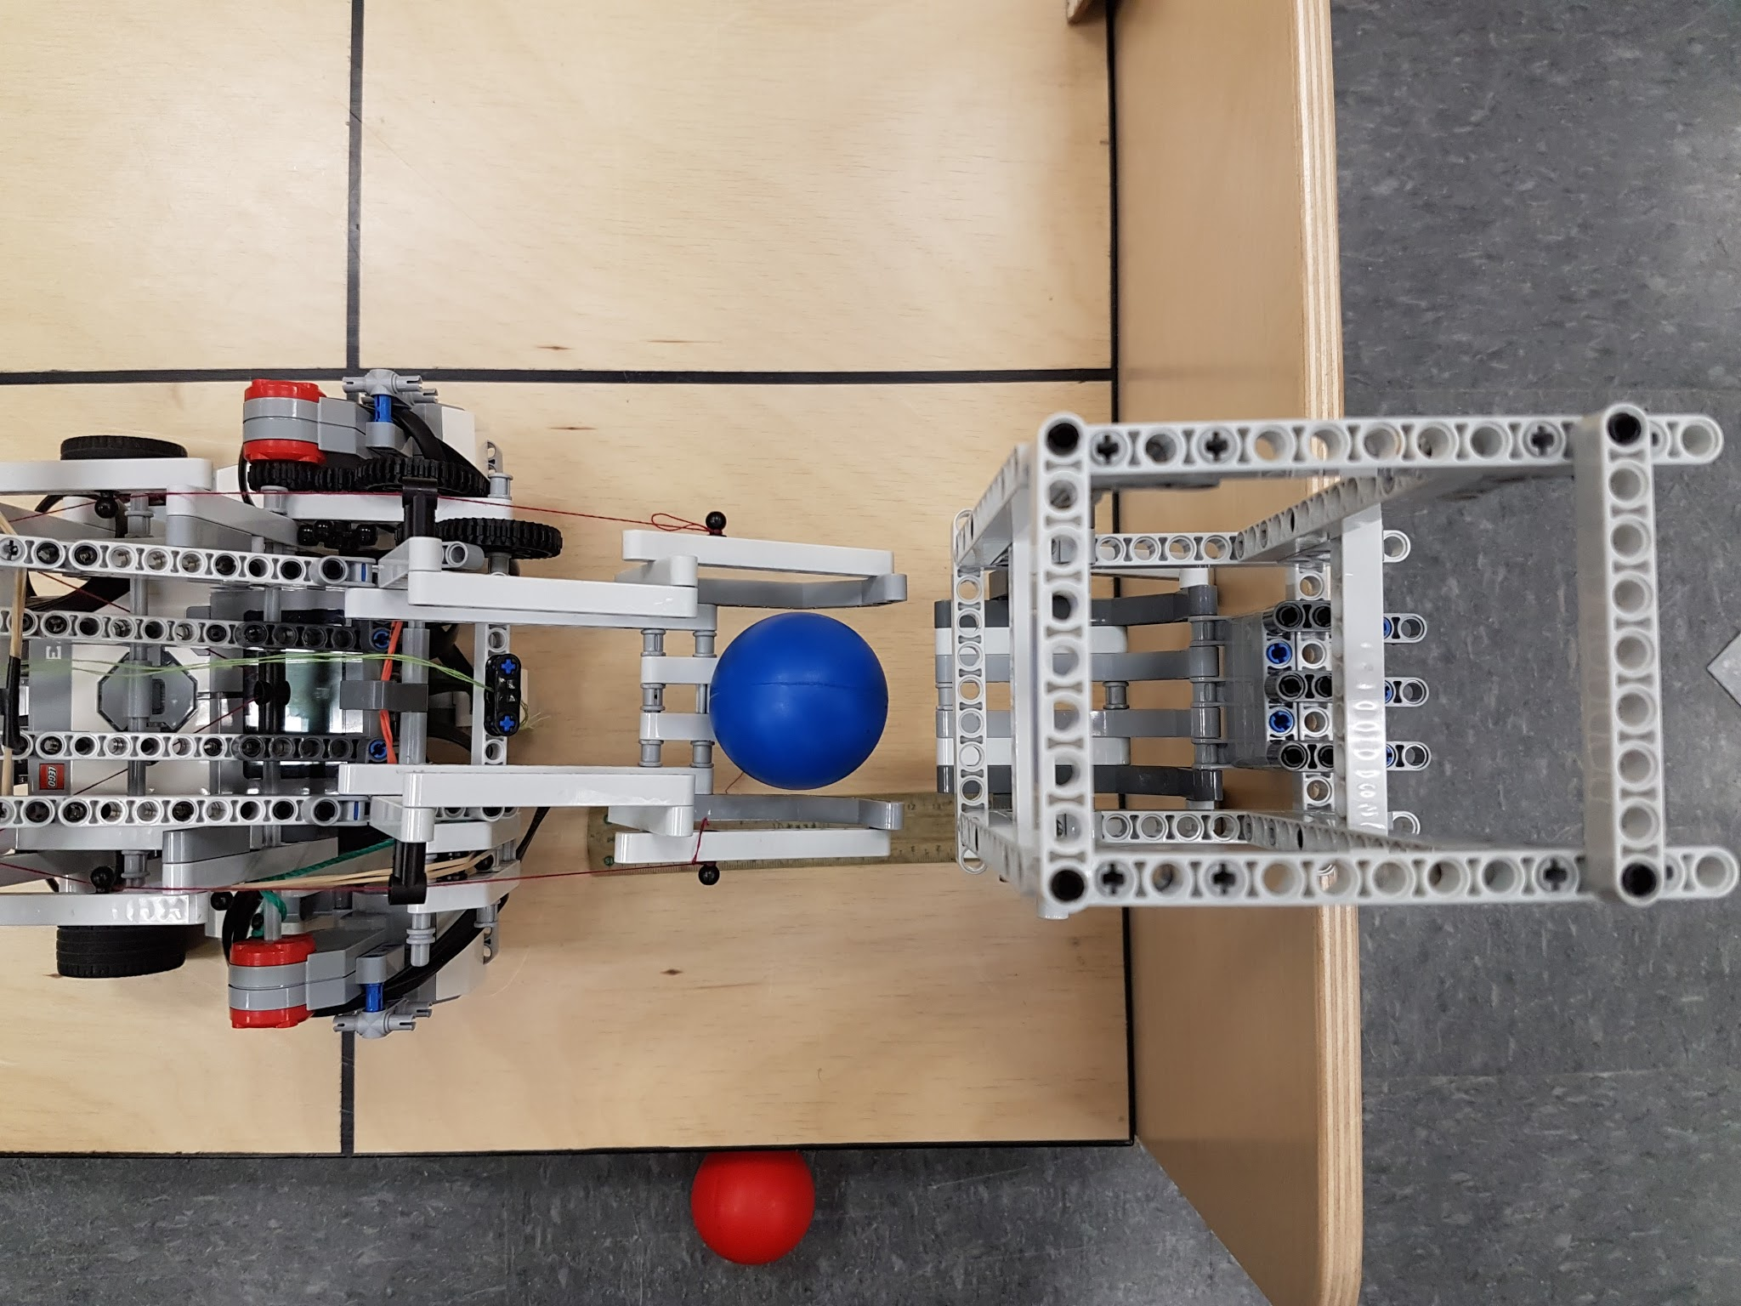

Varying x and setting y at 0 cm

|  |  |
| --- | --- |
| Distance between Robot and Dispenser (in cm) | Did the ball lend in the reservoir?* |
| 0.5 | Yes |
| 1 | Yes |
| 1.5 | Yes |
| 2 | Yes |
| 2.5 | Yes |
| 3 | No |
| 2.9 | No |
| 2.8 | Yes |

Varying y and setting x at 2.5 cm

|  |  |
| --- | --- |
| Distance between Robot and Dispenser (in cm) | Did the ball lend in the reservoir?* |
| 0.5 | Yes |
| 1 | Yes |
| 2 | Yes |
| 3 | Yes |
| 3.5 | Yes |
| 4 | No |
| 3.75 | No |
| 3.5 | No |
| 3.4 | No |
| 3.3 | Yes |

(*) Is successful when 8 or more out of 10 trials are successful

Conclusion: the V2 “Ball Reloading and Reservoir Mechanism” has an acceptable error of

[2.8; 3.3] cm.